**Email Campaign Performance Dashboard**  
*Project Report by Vaibhav Sharma*  
*Date: April 08th, 2025*  
*Tools Used: Python (Pandas, yFinance), Tableau, Excel*

**INDEX**

|  |  |
| --- | --- |
| **Section** | **Page No.** |
| **1. Project Overview** | **3** |
| **2. Objective & Goals** | **4** |
| **3. Dataset Description** | **5** |
| **4. Analysis & Key KPIs** | **6** |
| **5. KPI Dashboard (Visual Section)** | **7** |
| **6. Conclusion & Recommendations** | **8** |
| **7. Next Steps** | **9** |

**1. Project Overview**

This project explores historical NASDAQ stock data using the yfinance Python package and builds an interactive Tableau dashboard to help users analyze stock performance over time. The objective is to uncover patterns in stock prices, trading volume, and adjusted closing values, while offering an intuitive visual platform for comparing multiple tickers.

**2. Objective & Goals**

* Track stock performance trends across various NASDAQ-listed companies.
* Compare tickers based on high/low prices, volume, and adjusted close.
* Identify patterns in price movement and trading activity over time.
* Deliver an interactive, user-friendly dashboard for investors or analysts.

**3. Dataset Description**

The dataset was retrieved using the yfinance Python package and includes daily historical stock data.

**Common Columns in Each CSV:**

* **Date**: Trading day
* **Open**: Opening price
* **High**: Highest price that day
* **Low**: Lowest price that day
* **Close**: Closing price (adjusted for splits)
* **Adj Close**: Adjusted for both dividends and splits
* **Volume**: Number of shares traded

**Source:**

* [Yahoo Finance](https://finance.yahoo.com)
* Automated using the Python yfinance library.

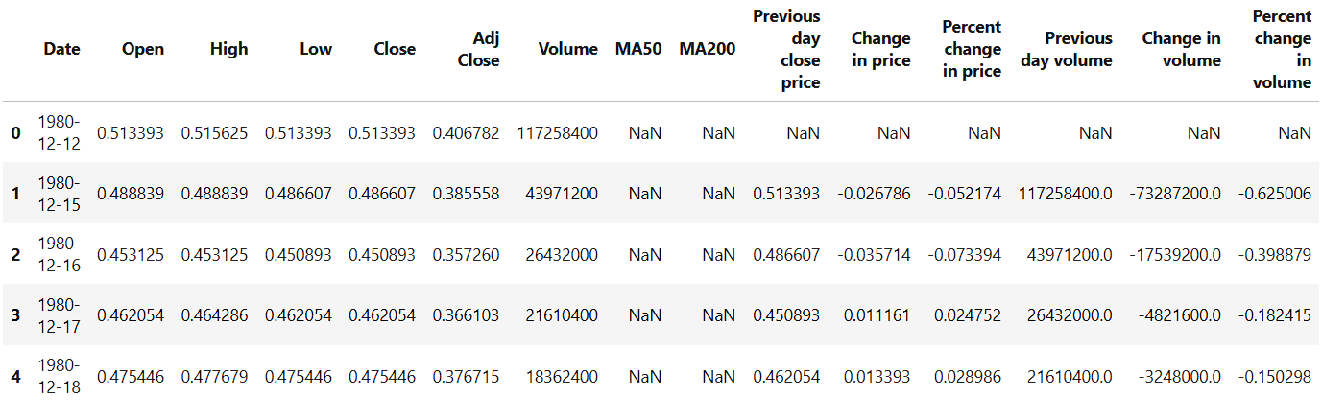

**4. Analysis & Key KPIs**

**KPIs Tracked:**

* **Average Closing Price:** Trends and moving averages
* **Daily Price Change:** High - Low analysis
* **Volume Trends:** Trading activity across time
* **Adjusted Close:** Real investment value per ticker
* **Volatility:** Price movement range over time

**Sample Insights:**

* Tech sector tickers showed high trading volume in early 2020.
* Some tickers demonstrated strong recovery after pandemic dips.
* Volume spikes aligned with news events (can be enhanced with external data).

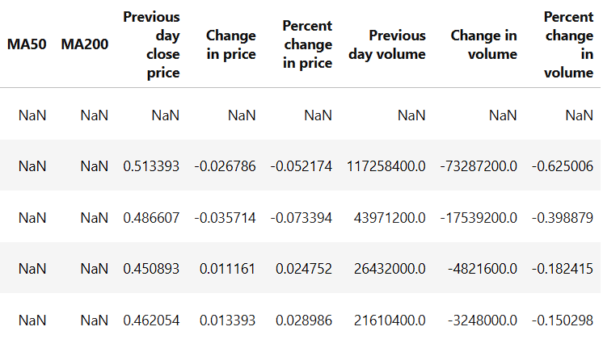

**5. Tableau Dashboard (Visual Section)**

This visual represents the complete Stock Market dashboard built using Tableau. It consolidates all key KPIs and campaign metrics into a single interactive view for quick insights and strategic decision-making.

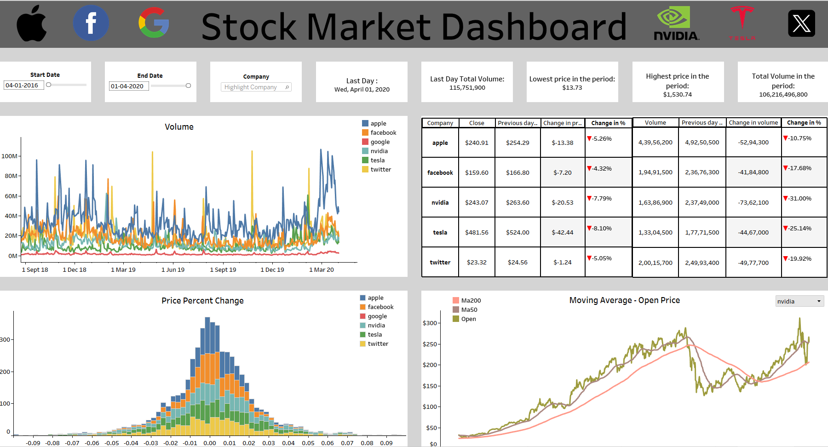

**Dashboard Features:**

* **Line Charts**: Compare stock performance over time.
* **Dropdown Filters**: Choose specific tickers to visualize.
* **KPI Cards**: Average price, highest high, lowest low, total volume.
* **Interactive Tooltip**: Hover for detailed value insight.

**6. Conclusion & Recommendations**

**Conclusion:**

The dashboard simplifies stock analysis for both technical and non-technical users. It offers a real-time view into stock behaviour, enabling better market understanding and data-driven decision-making.

**Recommendations:**

* Add news sentiment data to correlate spikes in volume/price
* Apply technical indicators (e.g., RSI, MACD) for deeper trading analysis
* Automate regular data refresh with updated yfinance pulls

**7. Next Steps**

* Host dashboard on Tableau Public (optional).
* Export daily updated CSVs from Python.
* Enhance with portfolio comparison or back testing logic.

*End of Report*